**Kraig Massee**

**Lab 3 Design**

**Step 1.**

**Purpose:** Allow program user to enter two numbers into text boxes to calculate various forms of mathematical operations using these numbers by button press with the result being outputted.

**Output:** The result of the mathematical operation the button press indicated. If the program user inputs invalid data a message box will display invalid input.

**Input:** Two numbers in separate text boxes.

**Process:** Add, Subtract, Multiply, Divide, Modulus, Power, the two numbers the program user puts in the text box after a button click of the respective operator. The result will be shown in a label.

**Step 2.**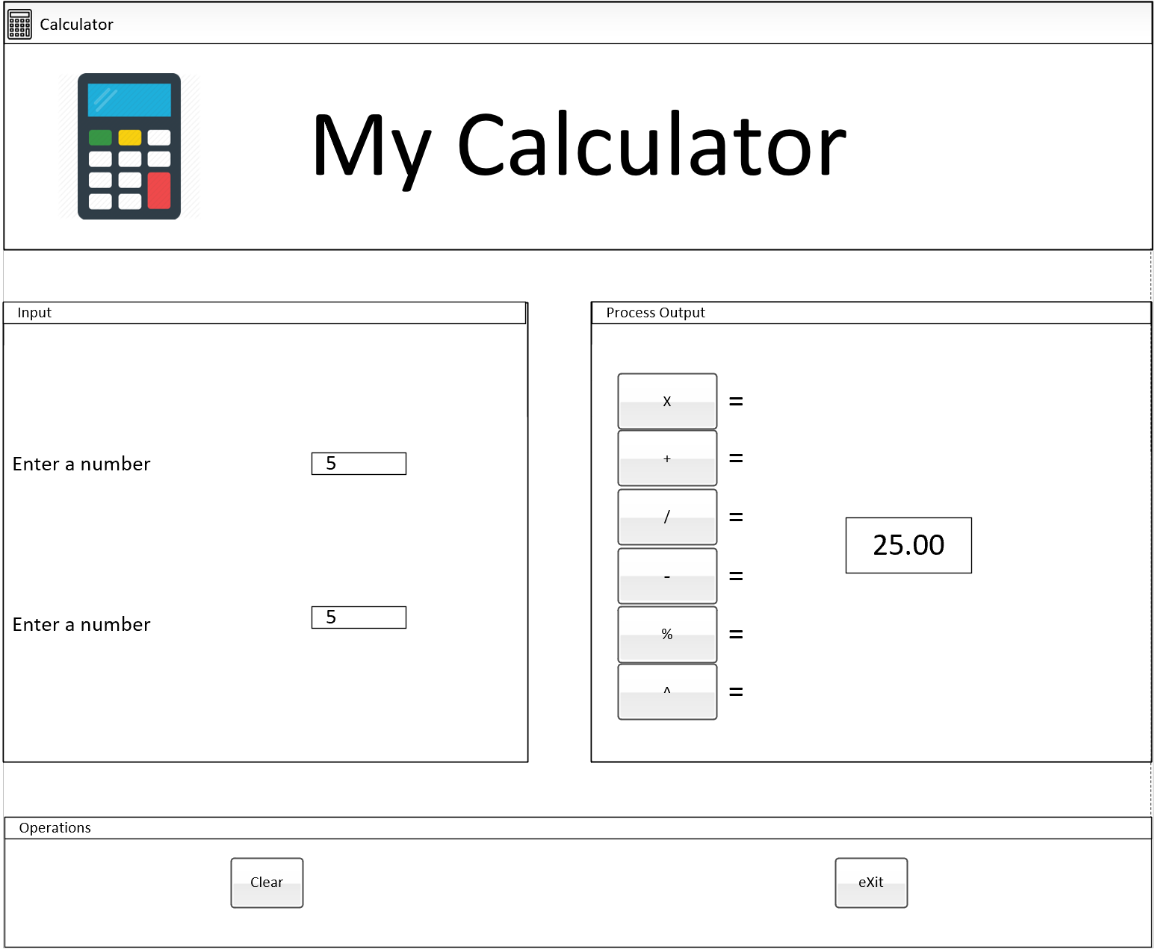

**Step 3.**

|  |  |  |
| --- | --- | --- |
| **Name** | **Description** | **Text** |
| calculatorForm | A form that serves as a window to hold the other controls | "Calculator" |
| calculatorImagePictureBox | A picture box control that holds the calculator image | "" |
| myCalculatorMainLabel | A Label holding the title of the calculator | "My Calculator" |
| enterNumberGroupBox | A group box holding the enter a number controls | "Input" |
| processOutputGroupBox | A group box holding the operator buttons and result label | "Process Output" |
| buttonGroupBox | A group box holding the clear and exit buttons | "Operations" |
| topEnterNumberLabel | The top label to identify the enter a number textbox | "Enter a number" |
| bottomEnterNumberLabel | The bottom label to identify the enter a number textbox | "Enter a number" |
| topNumberTextBox | The numerator area the program user enters a number | "" |
| bottomNumberTextBox | The denominator area the program user enters a number | "" |
| resultDisplayLabel | The label in which the result of the operation will be displayed | "" |
| multiplicationButton | Multiplies the numbers in topNumberTextBox and bottomNumberTextBox and displays them in resultDisplayLabel | "X" |
| additionButton | Adds the numbers in topNumberTextBox and bottomNumberTextBox and displays them in resultDisplayLabel | “+” |
| divisionButton | Divides the numbers in topNumberTextBox and bottomNumberTextBox and displays them in resultDisplayLabel | "/" |
| differenceButton | Subtracts the numbers in topNumberTextBox and bottomNumberTextBox and displays them in resultDisplayLabel | “-“ |
| modulusButton | Performs modulus operation on the numbers in topNumberTextBox and bottomNumberTextBox and displays them in resultDisplayLabel | "%" |
| powerButton | Performs exponent operation on the numbers in topNumberTextBox and bottomNumberTextBox and displays them in resultDisplayLabel | "^" |
| clearButton | Clears the text boxes and the resultDisplayLabel | "Clear" |
| exitButton | Exits the program. A message box will display “The Program will be terminated” | “eXit |
| toolTipInformation | Holds tool tip properties | "" |

**Step 4.**

|  |  |
| --- | --- |
| **Method** | **Description** |
| multiplicationButton_Click | Performs multiplication operator on boxOne, boxTwo, which are set to the number entered in topNumberTextBox and bottomNumberTextBox. Has exception handling for non-numbers that will show a message box saying to enter a valid number. |
| additionButton_Click | Performs addition operator on boxOne, boxTwo, which are set to the number entered in topNumberTextBox and bottomNumberTextBox. Has exception handling for non-numbers that will show a message box saying to enter a valid number. |
| differenceButton_Click | Performs difference operator on boxOne, boxTwo, which are set to the number entered in topNumberTextBox and bottomNumberTextBox. Has exception handling for non-numbers that will show a message box saying to enter a valid number. |
| divisionButton_Click | Performs division operator on boxOne, boxTwo, which are set to the number entered in topNumberTextBox and bottomNumberTextBox. Has exception handling for non-numbers and dividing by zero that will show a message box saying to enter a valid number. |
| modulusButton_Click | Performs mod operator on boxOne, boxTwo, which are set to the number entered in topNumberTextBox and bottomNumberTextBox. Has exception handling for non-numbers that will show a message box saying to enter a valid number. |
| powerButton_Click | Performs exponential function on boxOne, boxTwo, which are set to the number entered in topNumberTextBox and bottomNumberTextBox. Has exception handling for non-numbers that will show a message box saying to enter a valid number. |
| clearButton_Click | Clears the values of topNumberTextBox.Text  bottomNumberTextBox.Text  resultDisplayLabel.Text |
| exitButton_Click | Displays message box with “The program will be terminated” Gives option to cancel exit or press OK to exit program |